Aftermarket Brush Enquiry Form

Contact Details:
Name |  | Company
Address
Postcode / Zip code |  | Tel
E-mail

BRUSH DETAILS
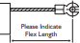
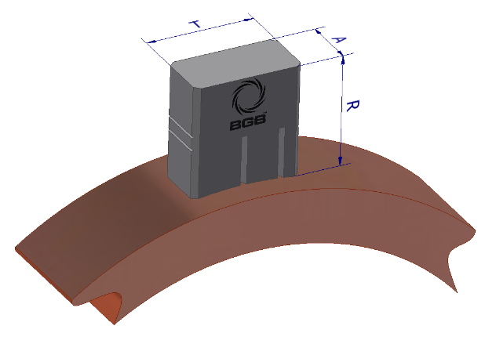
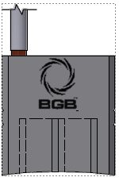
Flex
Contact face radius
Tangential Dimension (mm) | T =
Axial Dimension (mm) | A =
Radial Dimension (mm) | R =
Contact face radius (mm)
No. of flexes
Terminal slot
Grade / Brush markings
Insulation on Flexes
Flex Length (top of carbon to centre of terminal slot)

Additional Information / Other features
(Insulation, tops, bevel angles, saw cuts, OEM part number etc.) If possible, provide sketch or send photo:

*Return form to: SALES@BGBINNOVATION.COM

